**General instructions on how to use the AD9081 with the ZCU102**

Jon.Kraft@analog.com, Dec 2023

Note: These were created, and verified to work, in Dec 2023. Things may have changed a bit since that time... But the general flow should be the same

1. Install the LIBIIO drivers
   1. These might already be on your computer (if you can run IIOscope, then these are probably on your computer)
   2. Otherwise, follow instructions here: <https://wiki.analog.com/sdrseminars>
2. Download the FPGA's SD Card here:
   1. <https://wiki.analog.com/resources/tools-software/linux-software/kuiper-linux>
      1. At the time of this guide, [2021_r2 release image](https://swdownloads.analog.com/cse/kuiper/image_2023-04-02-ADI-Kuiper-full.zip) was used.
   2. You can burn image files using Win32DiskImager, on an ADI computer. It won't corrupt the SD card.
3. Move the AD9081/ZCU102 files on the SD card:
   1. **You must do this on a non-ADI computer!** Moving these files on an ADI computer will corrupt the SD card!
   2. <https://wiki.analog.com/resources/eval/user-guides/ad9081_fmca_ebz/quickstart/zynqmp#sdcard_boot_files>
   3. Copy these files to the SD card root: Image, BOOT.BIN, and system.dtb
      1. Copy the Image file from the zynqmp-common directory.
         1. Note: it is the "zynqmp-common" directory, not the "zynq-common" directory
      2. Copy the BOOT.BIN and system.dtb from the zynqmp-zcu102-rev10-ad9081-m8-l4 directory.
         1. For evaluation boards populated with VXCO 100 MHz copy the device tree from vcxo100 folder.
         2. For evaluation boards populated with VXCO 122.88 MHz copy the device tree from vcxo122p88 folder.
         3. The VCO is the large silver "box" on the back of the AD9081/2 eval board. Just read the label on it.
4. Configure ZCU102 board like this:
   1. <https://wiki.analog.com/resources/eval/user-guides/ad9081_fmca_ebz/quickstart/zynqmp#testing>
   2. Connect SMA cable, with a 20dB attenuator, between Rx0 and Tx0
   3. See photo below of the completed setup
5. Using a USB to Ethernet adapter, configure a static IP
   1. Go to network properties on your Windows computer, find that Ethernet device, right click and select "Properties"
   2. We'll set a static IP connection, so make sure that the IP address field is 192.168.0.2

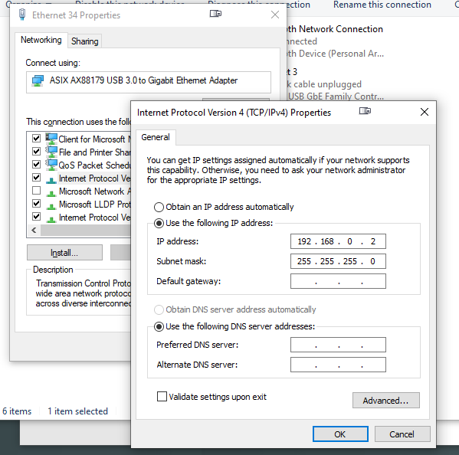

1. Configure the IP address of the FPGA board
   1. Power up the ZCU102 FPGA board, and wait about a minute
   2. Open up device manager on your laptop, select Ports, and find the "Silicon Labs Quad xxxxx: Interface 0

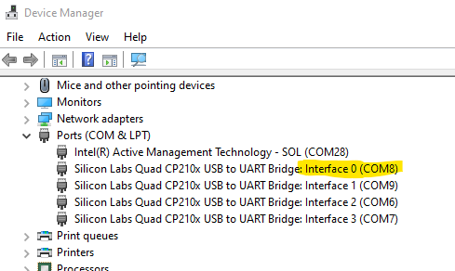

1. Now open the application "[PuTTY](https://www.putty.org/)" and enter in that COM port, Speed=115200, Connection Type=Serial

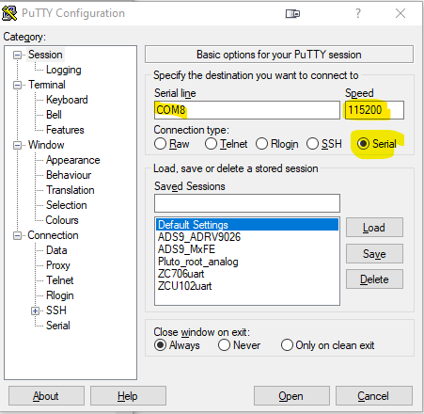

1. At the "root@analog:" command prompt type: enable_static_ip.sh 192.168.0.21

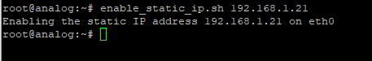

1. Now type: ifconfig eth0 192.168.0.10

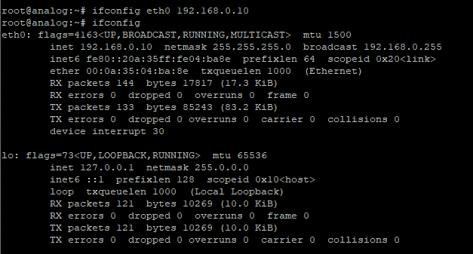

1. Let's find out what's connected to the ZCU102!
   1. Type: iio_attr -a -d



1. This should show you have an "AD9081-FMCA-xxxx" connected. And that it has iio devices for HMC7044, 9081-tx, and 9081-rx. See above image.
2. If you don’t see this, there is something wrong with your eval board (or it's not plugged in!)

1. Now open IIO Oscilloscope (osc.exe) on your windows computer
   1. Go to Settings --> Connect
   2. Select "Manual" and enter: ip:192.168.0.10
   3. Click "Refresh"

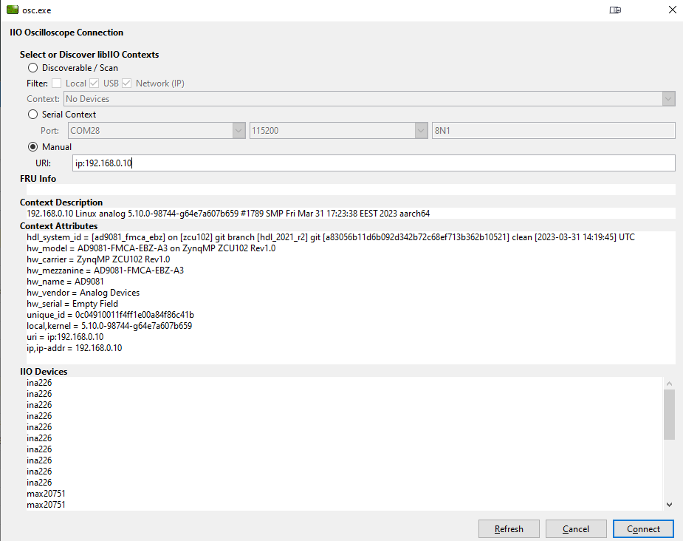

1. Then click "Connect"
2. Now let's configure the AD9081 to output 2 tones (3 MHz and 5 MHz) at 750MHz:

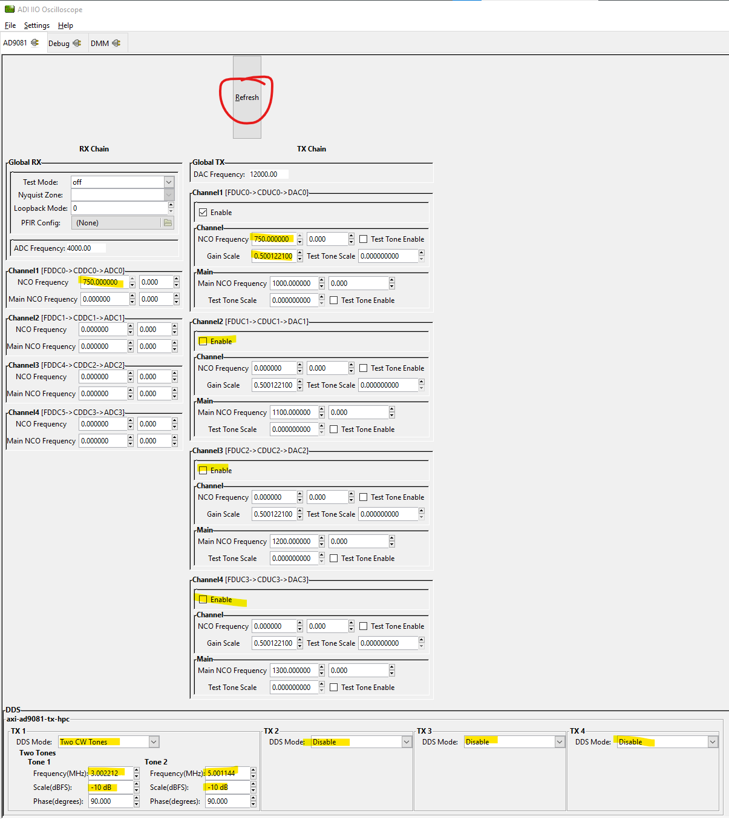

1. Hit "Refresh" to make sure all the values are accepted.
2. Then Select File=-->New Plot, click on "voltage0_i", "voltage0_q". Plot type = "Frequency Domain", then play button:

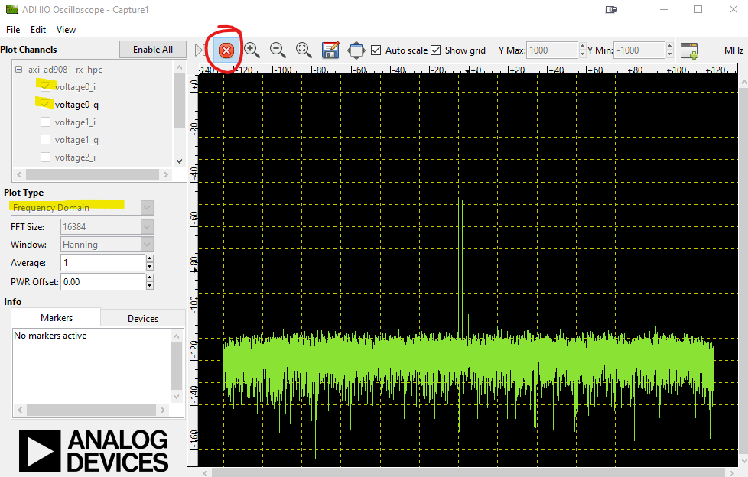

1. Ok, if you can do all of that, then we're ready to start programming!
   1. **If you can't do that, then DO NOT proceed further!** You've got to get this much working.
   2. But be encouraged! Establishing the connection is often the most frustrating part of the whole process. And you only need to do this setup once--everything will be remembered next time you power up. So once you get it working, it'll only get more fun!

1. Now you are ready to connect to Matlab or Python. See the other docs for help with that!

